QUESTION 1
- Compare the poetic text (provided below in its original form) to the musical score (provided in the Exam #2 folder on BlackBoard). How does the composer treat the poetic text?
O let me weep! O let me forever weep!
My eyes no more shall welcome sleep:
I'll hide me from the sight of day,
and sigh my soul away.
O let me weep! O let me forever weep!
He's gone, his loss deplore;
and I shall never see him more.

 | 1. | the composer states the poetic text in its entirety, without altering any of the lines
 | 2. | the composer repeats certain words/phrases, especially highly emotional words/phrases like “no more,” “forever,” “sigh,” and “never”
10 points

QUESTION 2
- The composer’s decision to repeat certain words/phrases hints at the ____________ of the character’s grief. Please select all answers that apply.

 | 1. | repetitiveness
 | 2. | timelessness
 | 3. | obsessiveness
10 points

QUESTION 3
- The composer further emphasizes the character’s emotional state by using a “ground bass,” a repeated musical phrase that (in this piece) haltingly descends along the chromatic scale. What did the ground bass symbolize during the Baroque era?
 | 1. | grief
 | 2. | desire
 | 3. | joy
 | 4. | anger
10 points

QUESTION 4
- The first iteration of the ground bass is shown in this image within a red rectangle. How many complete iterations of the ground bass—including the one shown in the red rectangle—do you see on this page (and/or hear in the first 1 minute and 25 seconds of the recording provided in the Exam #2 folder on BlackBoard)? [Hint: Focus on the sequential arrangement of pitches rather than the specific note lengths, which occasionally vary from the original statement of the ground bass.]
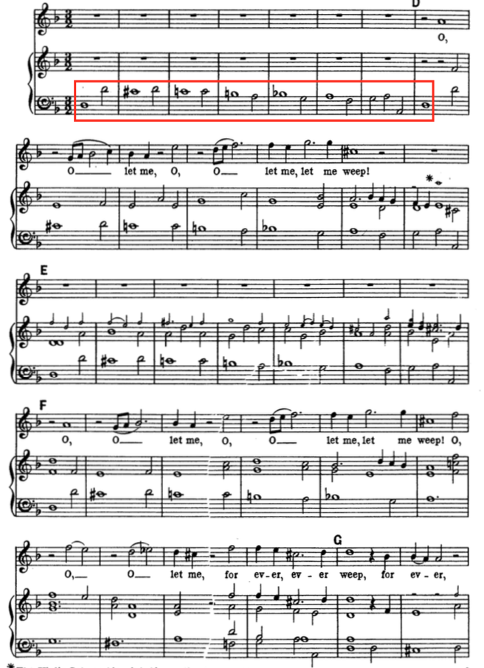

2
3
4
5
10 points

QUESTION 5
- Throughout this piece, the music occasionally reflects the meaning of certain words. What is this compositional technique called?

 | 1. | harmonization
 | 2. | word painting
 | 3. | improvisation
 | 4. | articulation
10 points

QUESTION 6
- How does the music reflect the meaning of the word “sigh” between 2:47 and 2:55 of the recording? Please select all answers that apply.
 | 1. | the singer’s voice slides from a higher note to a lower note, as if she is actually sighing
 | 2. | the instruments shift from a higher note to a lower note, as if they are sighing
10 points

QUESTION 7
- How does the music reflect the meaning of the word “gone” between 4:59 and 5:14 of the recording?
 | 1. | the singer performs the word “gone” without any instrumental accompaniment at all (in other words, a capella)
 | 2. | the accompanying instruments—often quite active and supportive throughout this piece—sustain a long chord whenever the singer performs the word “gone,” making it sound as if the singer is suddenly alone
10 points

QUESTION 8
- What performing forces do you identify in this recording? Please select all answers that apply.
 | 1. | soprano
 | 2. | harpsichord or lute
 | 3. | piano
 | 4. | cello
 | 5. | violin
10 points

QUESTION 9
- At 00:23-00:37, both the voice and the cello—which continues to play the ground bass—vie for the listener’s attention, suggesting that the texture here could be described as which of the following:
 | 1. | heterophonic
 | 2. | monophonic
 | 3. | homophonic
 | 4. | polyphonic
10 points

QUESTION 10
- What Italian word would you choose to describe the tempo of this performance?
 | 1. | accelerando
 | 2. | a capella
 | 3. | andante
 | 4. | allegro
10 points

QUESTION 11
- Click on any musical note in this phrase involved in conjunct motion.
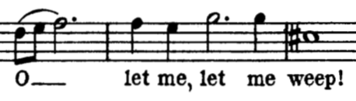
Selected CoordinatesClear
major second
10 points

QUESTION 12
- Click on any musical note in this phrase involved in disjunct motion.
Selected CoordinatesClear
minor second
10 points

QUESTION 13
- In this passage, the performer sings the word “O” over three musical notes (three notes per syllable), as shown in this image. How would you describe this type of text-setting?

 | 1. | neumatic
 | 2. | melismatic
 | 3. | syllabic
10 points

QUESTION 14
- In this passage, the performer sings each of the words “let me, let me weep” on an individual musical note (one note per syllable), as shown in this image. How would you describe this type of text-setting?
 | 1. | melismatic
 | 2. | syllabic
 | 3. | neumatic
10 points

QUESTION 15
- If you closely compare the recording to the musical score, you can hear that the singer sometimes sings slightly different notes from those notated. During the Baroque era, singers were expected to be able to elaborate on what was written in the musical score, much like jazz and pop musicians do today. What is this technique called?
 | 1. | articulation
 | 2. | improvisation
 | 3. | harmonization
 | 4. | tonicization
10 points

QUESTION 16
- This piece that you are studying for Exam #2 is drawn from a large-scale dramatic work that combines poetry, acting, scenery, and costumes with singing and instrumental music. What is this genre called?
 | 1. | oratorio
 | 2. | cantata
 | 3. | concerto
 | 4. | opera
10 points

QUESTION 17
- Two major components of this genre are arias and recitatives. How would you define an aria?
 | 1. | speechlike declamations of the text that help to move the dramatic action forward
 | 2. | lyrical songs in which time seems to stop in order to allow characters to express their emotions
 | 3. | none of the above
10 points

QUESTION 18
- Two major components of this genre are arias and recitatives. How would you define recitative?
 | 1. | lyrical songs in which time seems to stop in order to allow characters to express their emotions
 | 2. | speechlike declamations of the text that help to move the dramatic action forward
 | 3. | none of the above
10 points

QUESTION 19
- Based on what you can glean from the content of the poetic text and the music itself, do you think that the unknown piece you are studying for Exam #2 is an aria or a recitative?
 | 1. | aria
 | 2. | recitative
10 points

QUESTION 20
- In this genre, what term is used to describe the poetic text?
 | 1. | chorale
 | 2. | libretto
 | 3. | madrigal
 | 4. | book
10 points

QUESTION 21
- This work was first performed in a space similar to the one shown in this image: a public theater. Based on what you know about the distinctions between private and public theater during the Baroque era, which would you expect to be true of this work?
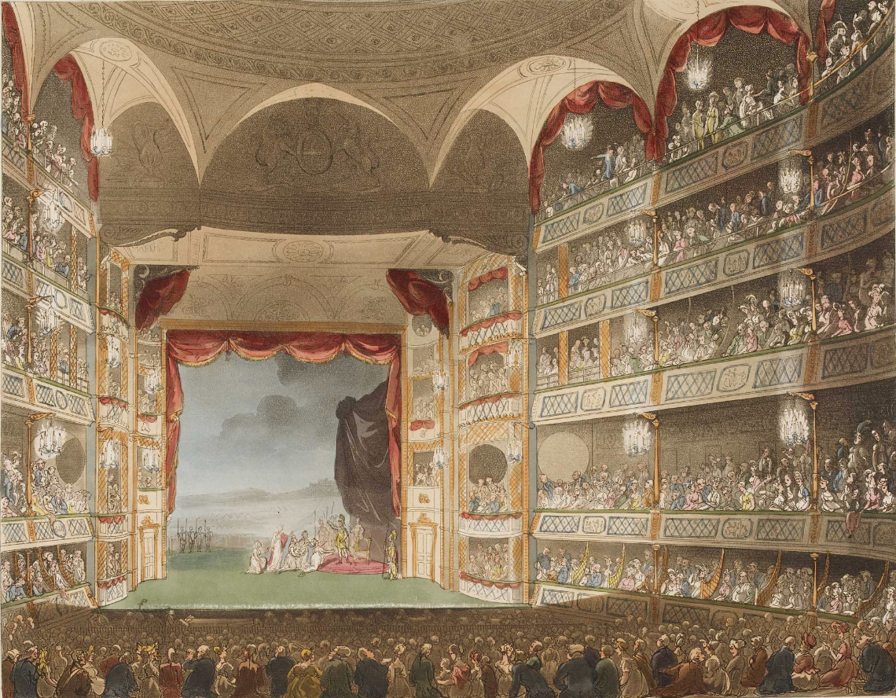
 | 1. | this work appeals to its noble patron by focusing on the heroic qualities of the main character (who is clearly meant to stand in the patron)
 | 2. | this work appeals to its audience by focusing on relatable themes, such as love and loss, and main characters with flaws of various kinds
10 points

QUESTION 22
- Based on when this genre became widely available to the middle classes who attended public theaters (rather than reserved for the nobility who had private court theaters), when must this work have been premiered?
 | 1. | in the mid-1600s or after
 | 2. | in the early 1600s
 | 3. | pre-1600s
10 points

